May 29 & May 30, 2026 at the Studio
(Dance class times listed separately)
Generations of Dance Picture Day Photo Order Form
(Bring this form to Picture Day to hand to the Photographer)
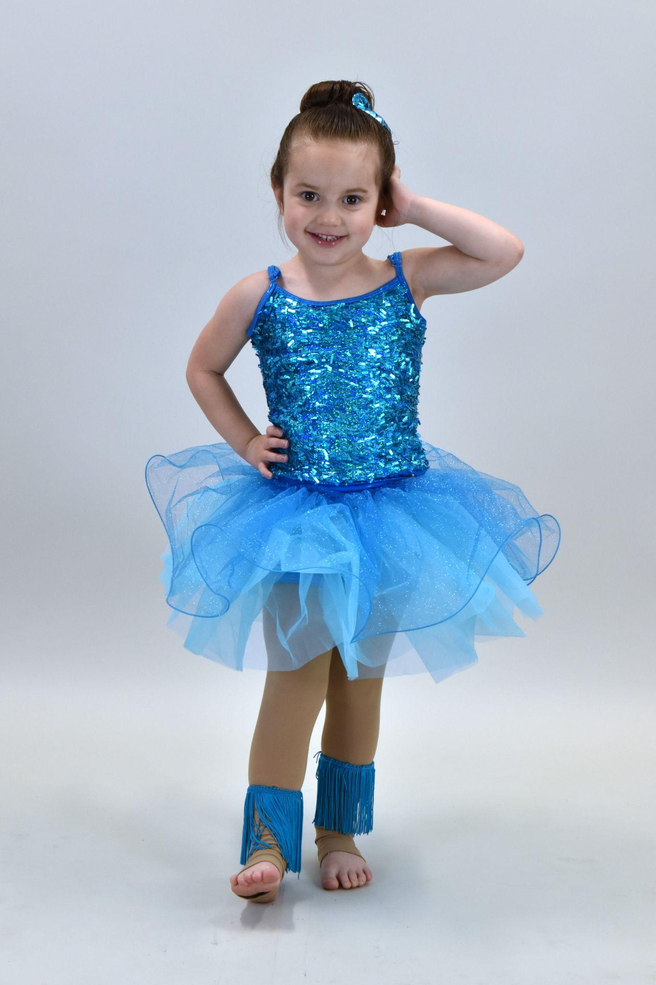
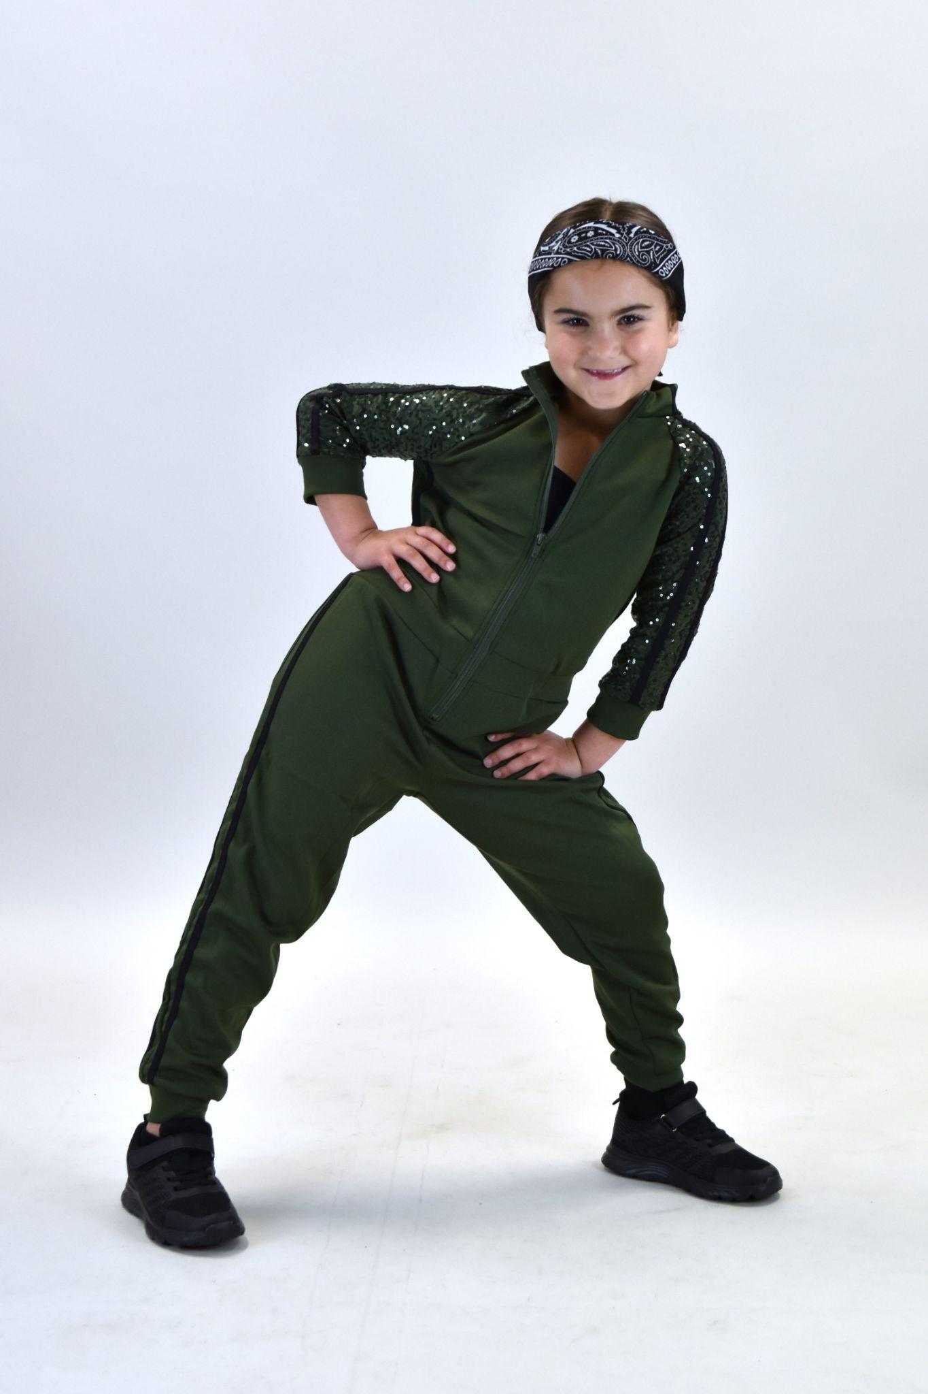
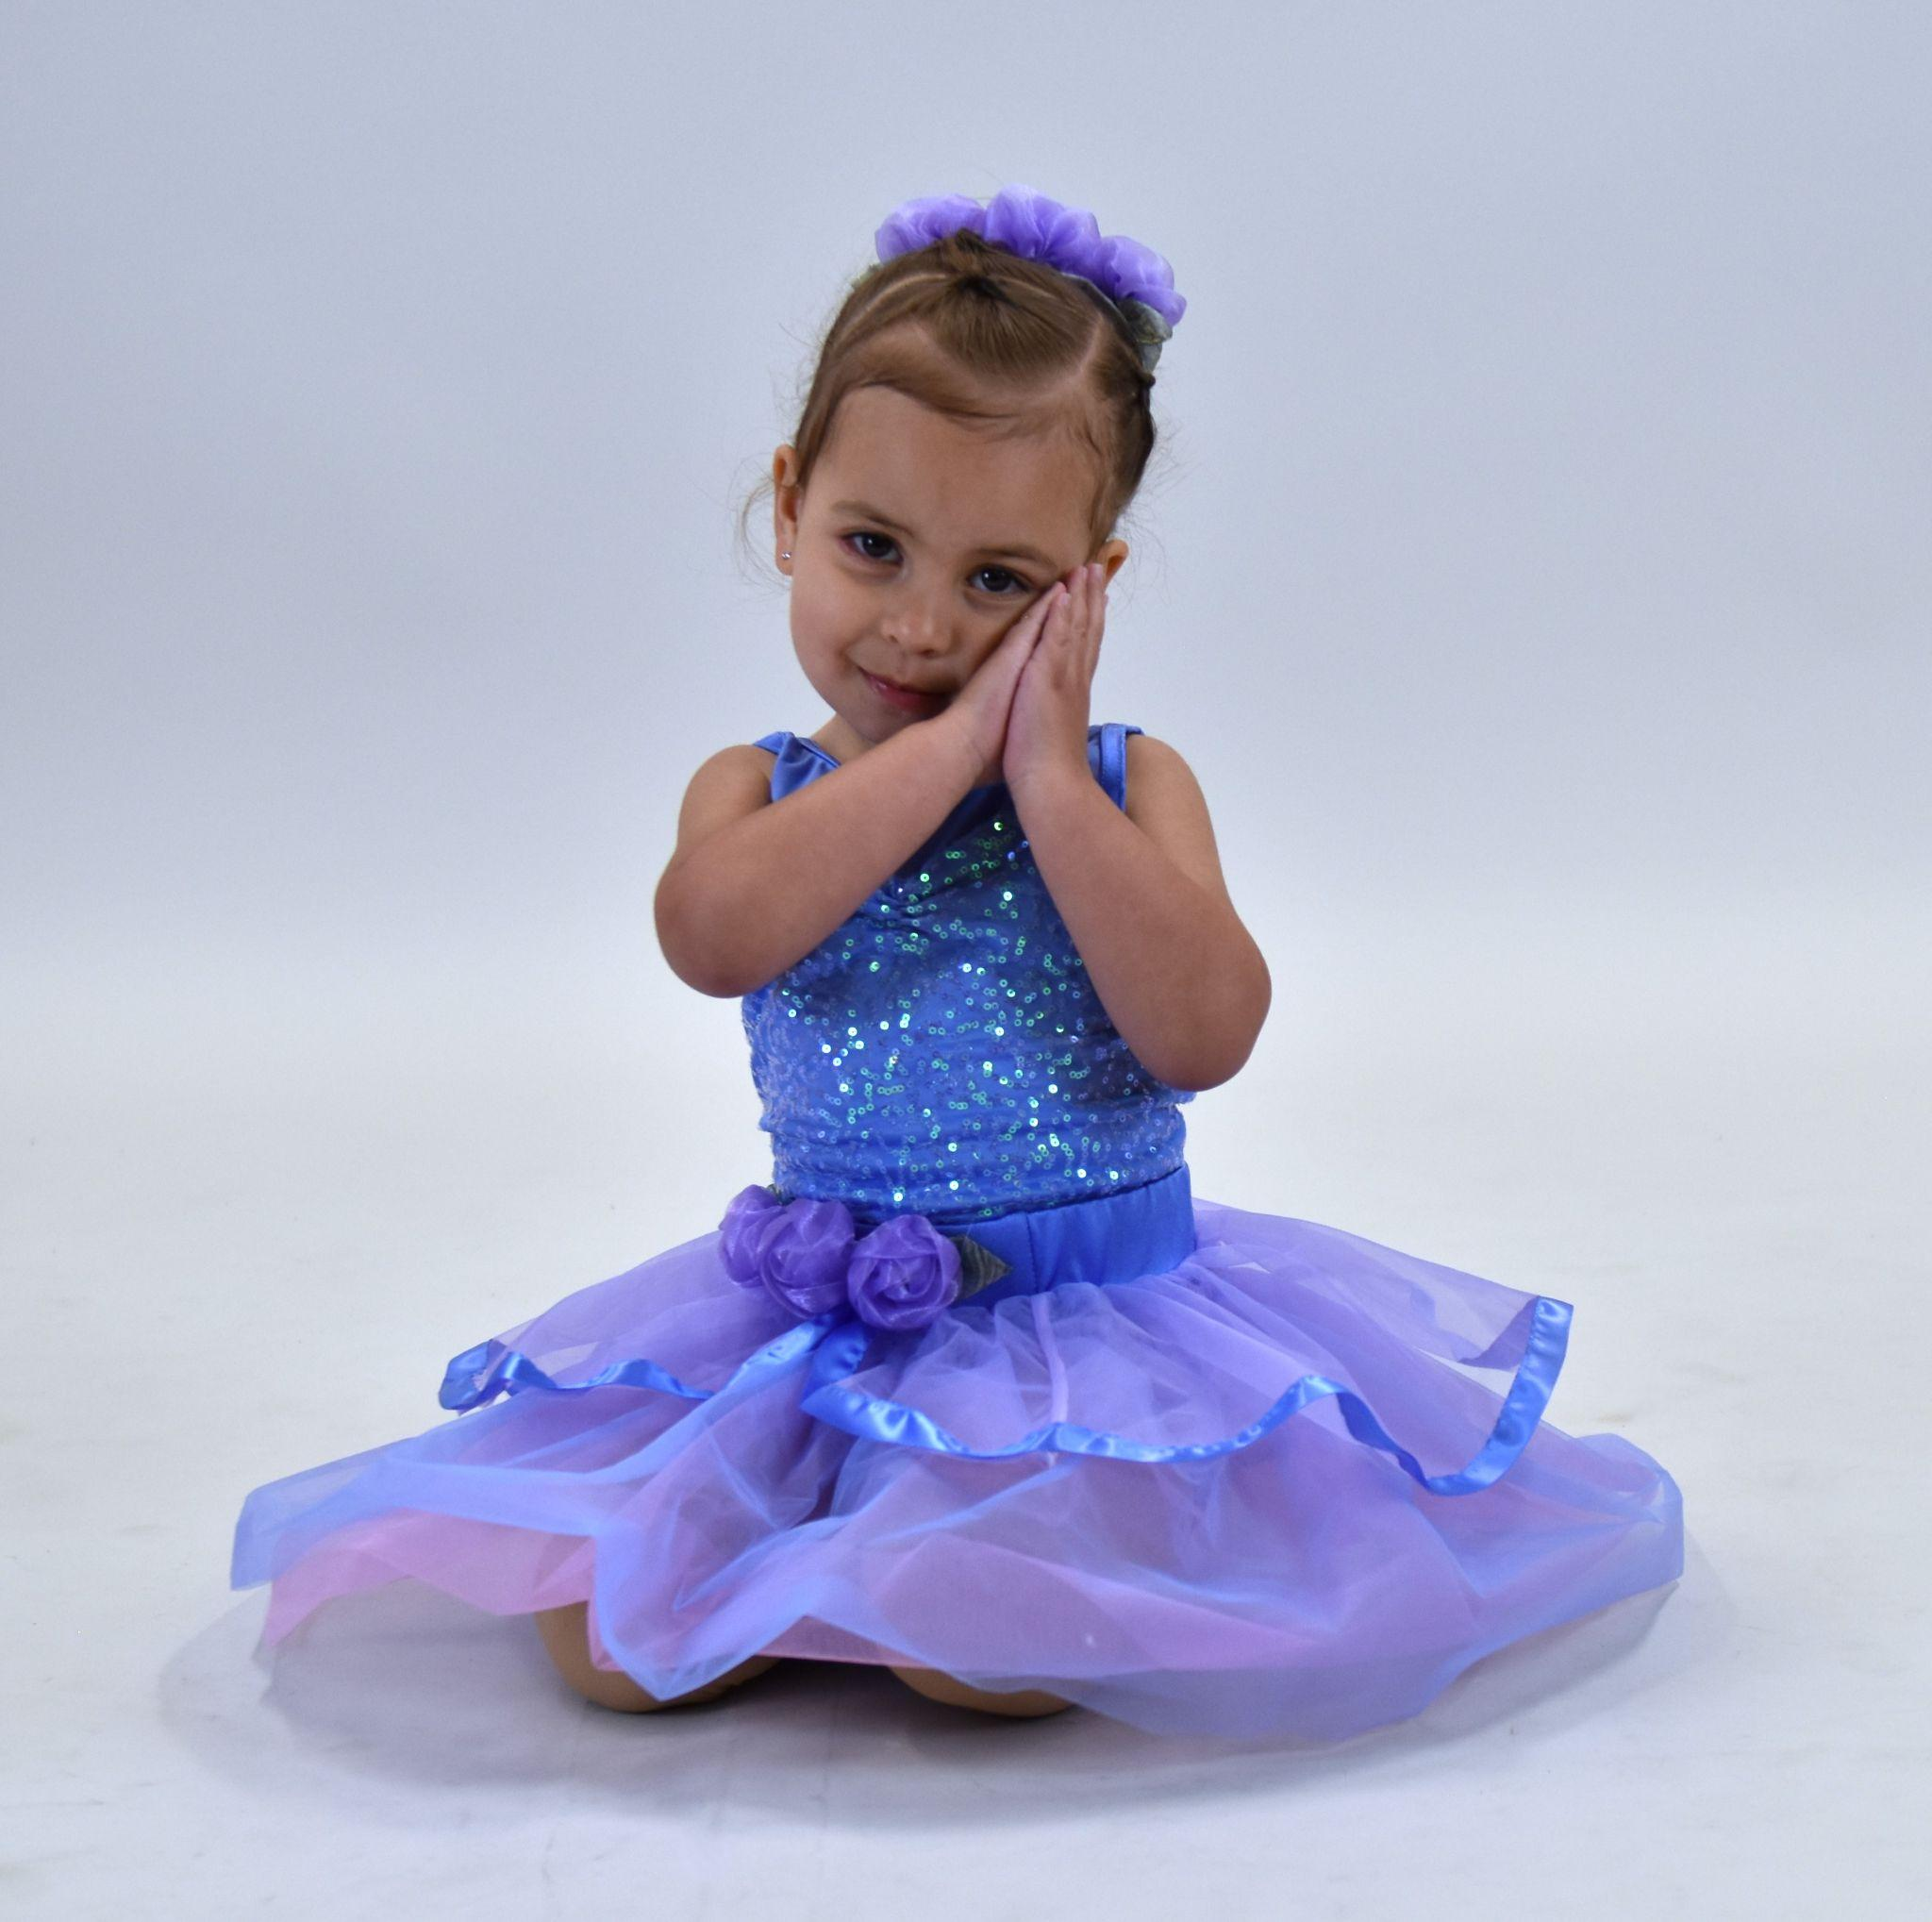
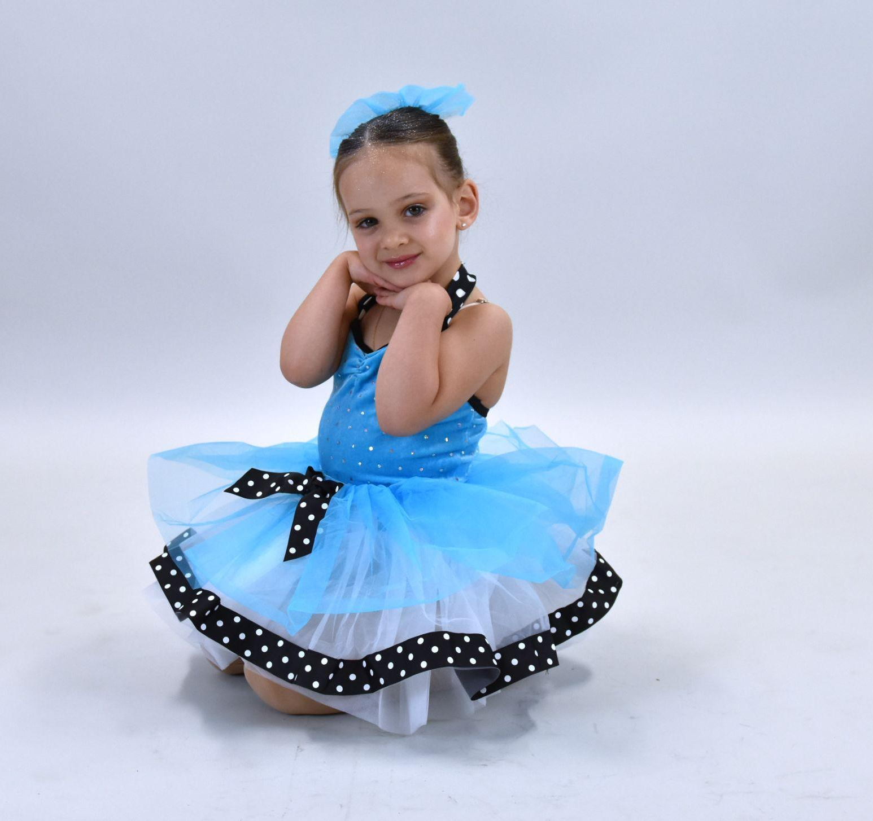
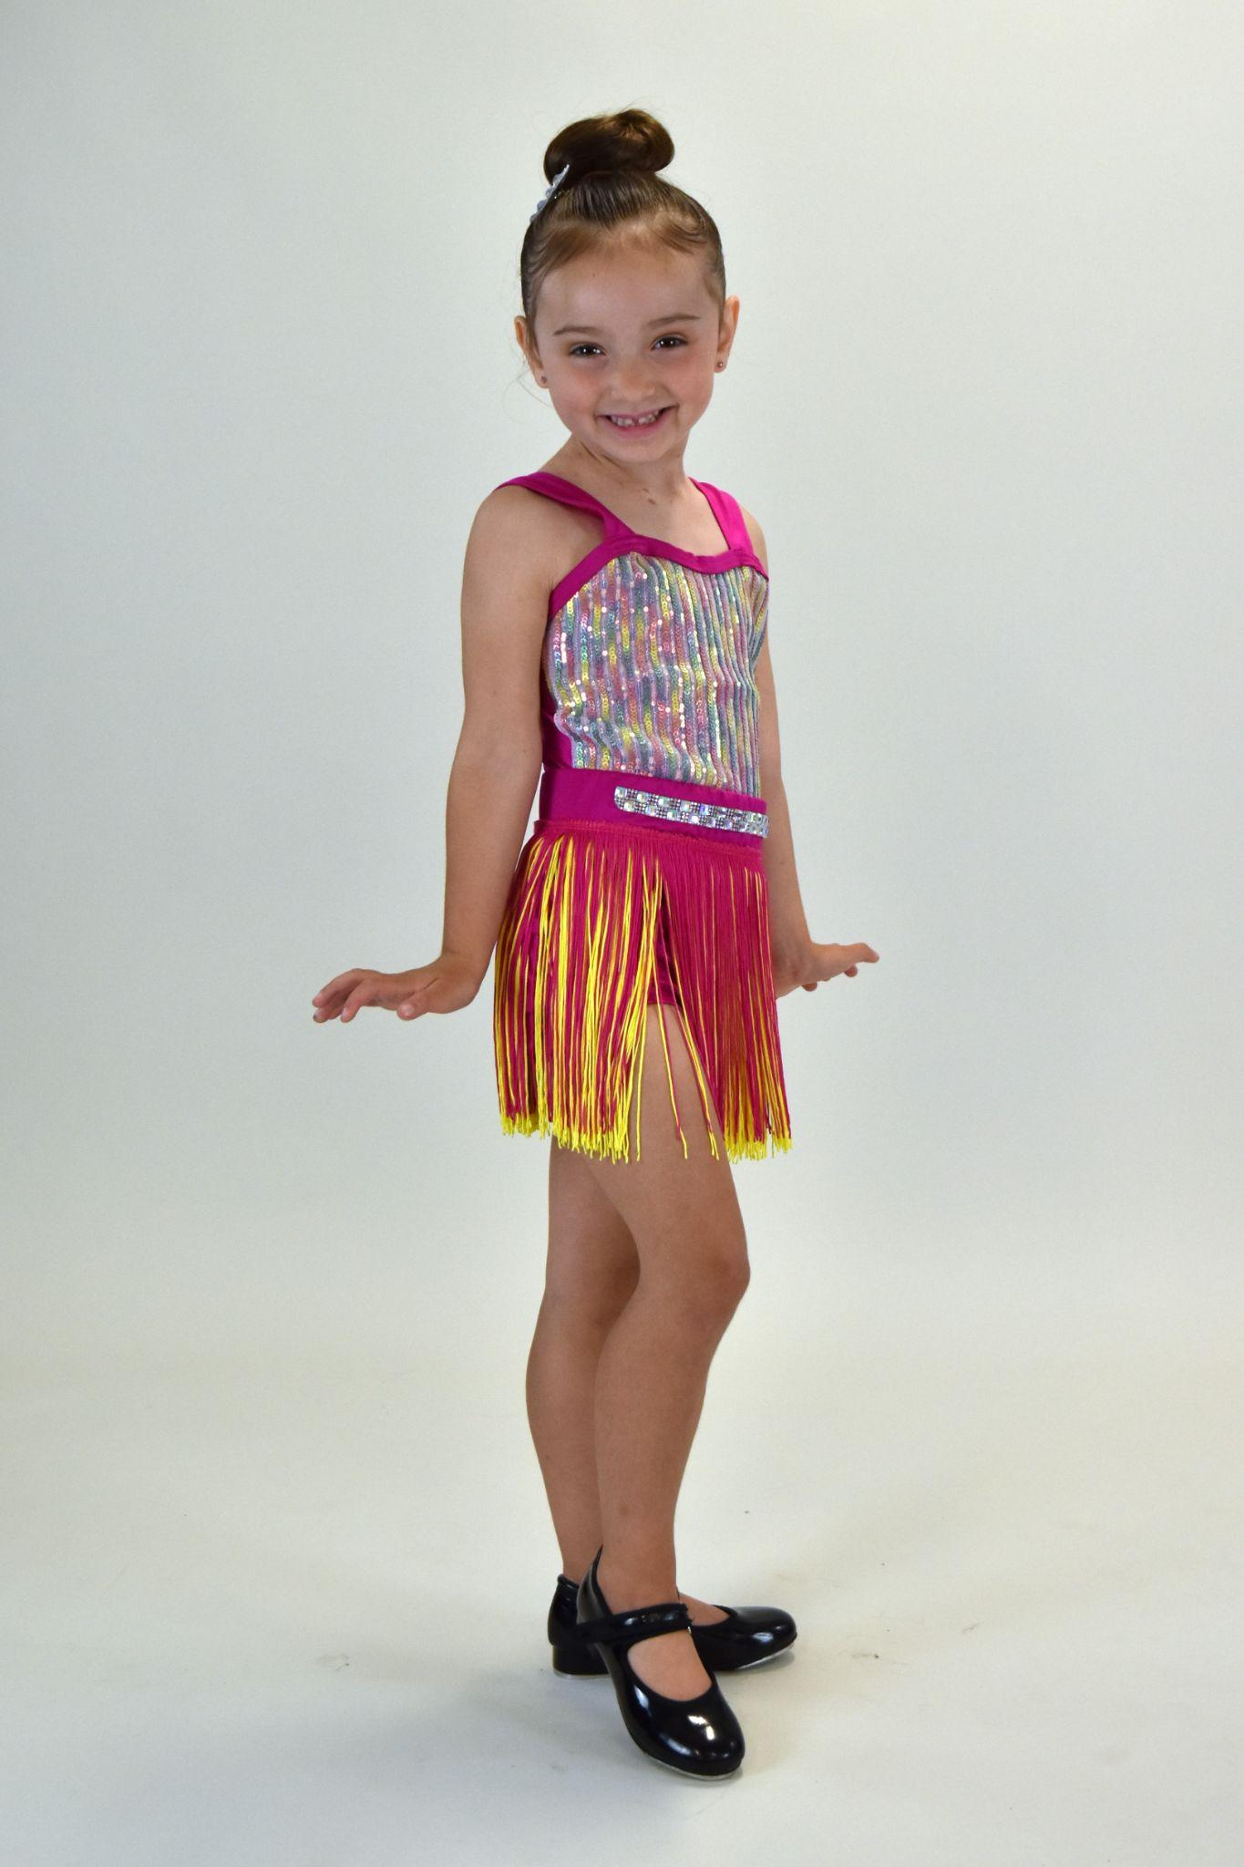
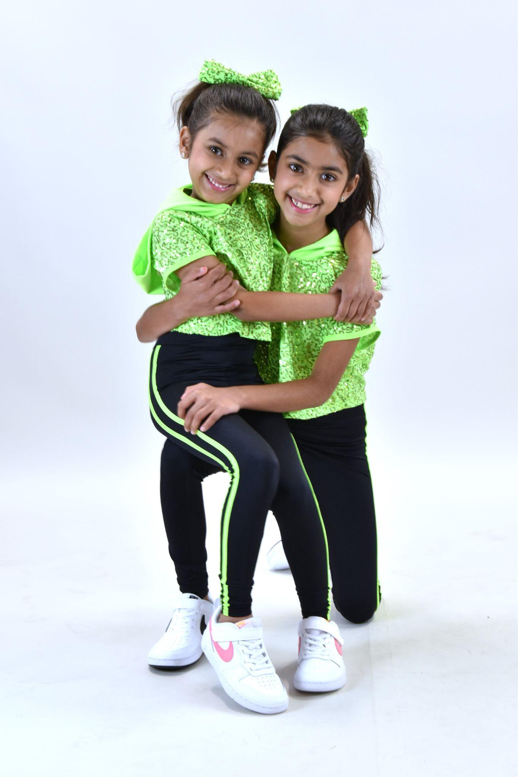
*****MUST BE PAID AT THE DAY OF PICTURE!!!

Photographer - Allyson Moreno**

$40 per photo session per costume
Class/Group Photos were included in the prepaid Recital Stuff Package
**If you would like an additional photo - $5

- We will try to get at least two different poses from your dancer during each session, sometimes more if they are happy to pose and smile! You will receive all photos from each session.
- A photo session can be one individual, a duet, a trio or siblings.
- High resolution pictures will be emailed to you and you can print/share however you would like.
- Payment is due the day of the picture via Check to Generations of Dance, Cash or Zelle to 973-985-7239. (please let us know if you need to make other arrangements)

Name/Child _______________________ Email____________________________
(please print clearly!!)
Cell______________________

Sessions #1_$____, costume brief description_________________________________
Sessions #2_$____, costume brief description_________________________________
Sessions #3_$____, costume brief description_________________________________
***Add other additional sessions on back
# of Additional Class Photos _________ (*1 included) Total Cost $___________
Paid date/via ___________________________ Zelle Check Cash (circle one)

Notes:_______________________________________________________________

**I do not consider myself a professional photographer but I love to play and am excited to capture pictures of your dancers for you!

